Decision support for forest management
  - Lecture 2 outline, Overview of decision support

Introduction
- Origins of contemporary decision science
  - Business schools at Yale, Harvard, and MIT – late 1950s into the 60s
- The Mintzberg planning model
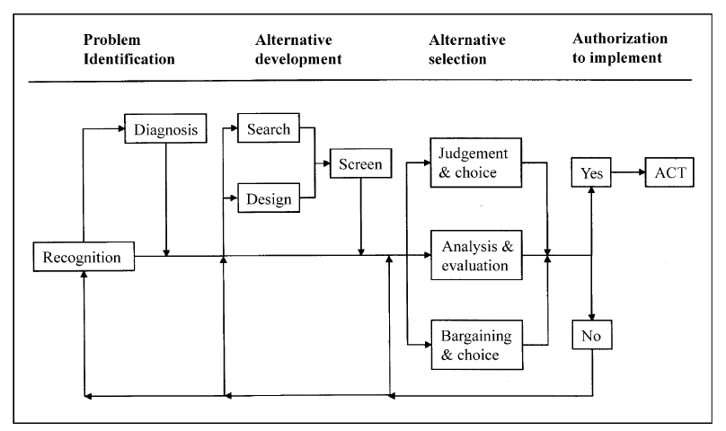
The Mintzberg planning process (Mintzberg et al. 1976), after Rauscher (1999). The Mintzberg process presents a general approach to planning, representing all, or at least most of, the classic variations on any planning process. Planning proceeds through the four steps of problem identification, alternative development, alternative selection, and a final decision to either implement the selected alternative, or cycle back to one of the first three steps. In each of the first three steps, multiple pathways are possible.
- What is a decision support system (DSS)?
  - A computer-based system composed of a language system, presentation system, knowledge system, and problem-processing system whose collective purpose is the support of decision-making activities. (Holsapple, 2003)
  - Two key attributes
    - A problem processing system
    - Purposeful support of a decision process
- Examples of systems that meet the Holsapple definition
  - Linear programming systems (goal programming, integer programming, etc.)
  - Expert systems (diagnosis, classification)
  - Bayesian networks
  - Multi-criteria decision analysis (AHP, PROMETHEE, etc.)
- Examples of systems that are not decision support systems per se
  - Statistical models
  - Simulation models
  - Spreadsheets (MS Excel)
  - Databases (MS Access)
  - GIS (ArcGIS)
- However:
  - All of the above may be important components
  - DSS applications may also be implemented in spreadsheets, databases, and GIS
  - Systems versus applications
- Evolution of DSS in forest management
  - 1970s – linear programming
  - 1980s – expert systems and MCDA
  - 1990s – spatial DSS
  - 2000s – integrated systems

Linear programming
- Optimization
  - Many different variations
  - Maximize/minimize a set of objectives subject to a set of constraints
    - E.g., maximize annual timber harvest with minimal impact to wildlife
  - Search solution space for the optimal answer
- Example FORPLAN (Johnson et al. 1986)
  - Developed in the 1970s
  - Primary planning tool for US National Forests from 1985 to 1995
  - Aspatial solution
  - Spatial successor was SPECTRUM in mid 90s
  - Problems
    - Ecosystem management
      - Dimensionality and complexity
    - Public involvement
      - Transparency
    - Fall from grace
  - SPECTRUM still in common use
    - But for narrower, more technical solutions
- Later examples
  - MARXAN (ref)
    - Design of biodiversity reserve systems
    - Simulated annealing (heuristic optimization)
    - Satisficing solutions
  - Optimizing design of road networks
    - E.g., optimizing travel time

Expert systems (classical)
- Also called knowledge-based systems (Walters and Nelson 1988)
- Evolved out of the early days of artificial intelligence in the 1960s and 1970s
- Basic idea – encapsulate the knowledge of experts on how to solve problems
  - Tacit knowledge
- Earliest applications in the medical field
  - E.g., disease diagnosis
- Common application areas
  - Diagnosis – why doesn’t my car start?
  - Classification – which insect pest is this?
  - Interpretation – is this a sustainable ecosystem?
- Components
  - Knowledge base (KB) – a collection of facts and rules
  - An engine – processes the facts and rules against new information
  - An interface
  - A language – well defined syntax and semantics
    - The KB is ontologically committed to the engine
- General classes of ES
  - Rule-based systems (Handout #1)
    - Forward chaining (predicate to consequent)
    - Backward chaining (consequent to predicate)
    - Special case – object based (see NetWeaver below)
  - Blackboard, frame- and agent-based systems (Handout #2)
    - Object oriented
    - Components with specialized knowledge
      - Attributes – facts and states pertinent to solving a problem
      - Procedural knowledge
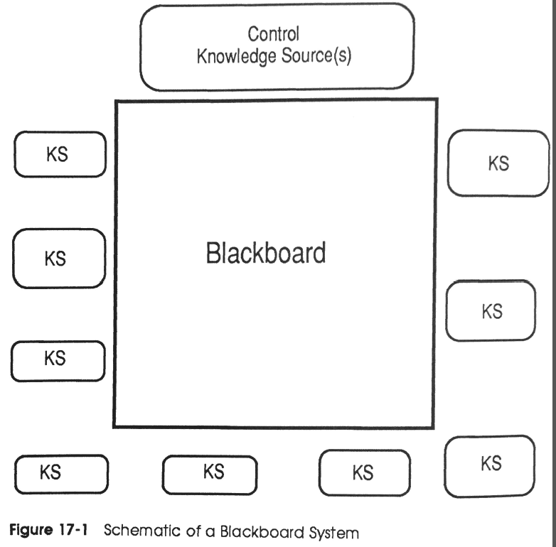

Bayesian decision networks
- A framework for probabilistic reasoning - Nyberg et al. 2006
  - A kind of expert system
- Structure
  - A network of nodes and directed links
  - Types of nodes
    - Input (or environment) node (e.g., aspect and stand age in figure)
    - Nature nodes (forest floor characteristics)
    - Decision nodes (stand removal and site preparation)
    - Utility nodes (logging cost/ha and regeneration cost/ha)
  - States
    - States of input nodes have a prior prob. distribution
      - Could be known or uniform
    - States of nature nodes have conditional probabilities determined by their parent nodes
    - States of decision nodes indicate (management) choices
    - Utility nodes assign a utility (cost/benefit) to choices in decision nodes
- In the figure, terrestrial lichen forage abundance represents the outcome
  - States in the outcome show the posterior probability of each state
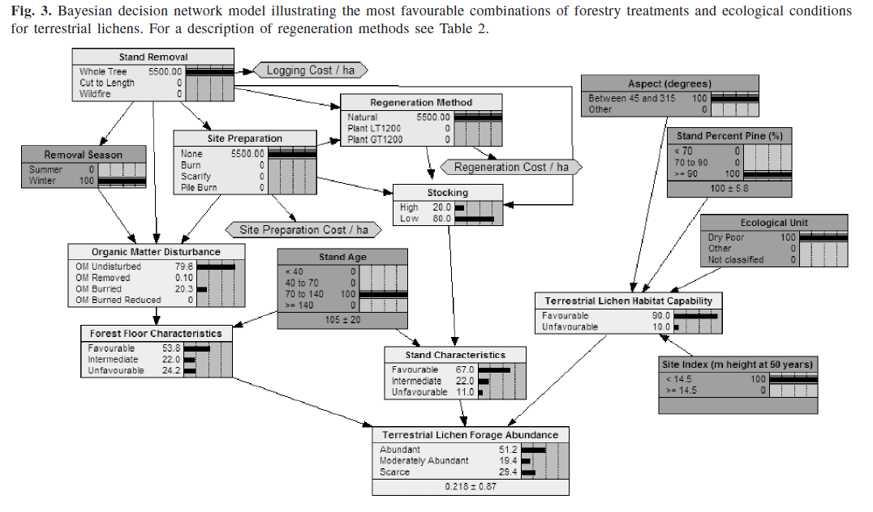
- Some advantages
  - Scientists comfortable with probabilistic reasoning
  - Not hard to implement in commercial software (e.g., Netica)
  - Initial model might depend heavily on subjective probs from experts
    - But conditional probs can be updated based on new observations

NetWeaver
- Object-oriented rule-base
  - Graphical representation
  - Cognitive theory - logical and spatial reasoning
  - Fuzzy logic (Zadeh 1965, 1968, 1975a, 1975b, 1976)
- Conclusions and premises
  - A network of networks - a recursive architecture (see figure)
Figure. A basic logic model to assess aquatic impacts in watersheds associated with atmospheric sulfur deposition. The model represents a formal logical discourse.
- Fuzzy logic versus classical logic
  - The concept of degree of set membership
  - Truth values and strength of evidence – the key metric of a network
- Some advantages
  - Can accommodate very complex, abstract problems (e.g., sustainability)
  - Very parsimonious representation compared to classical rule bases or Bayesian models

Multi-criteria decision systems
- A structured approach to decision making.
- Various approaches have been devised since the late 1970s.
- Two of the most popular methodologies
  - Analytic Hierarchy Process (AHP, Saaty 1992).
  - The Simple Multi-attribute Rating Technique (SMART, Kamenetzky 1982).
- The AHP approach
  - Goal, criteria (and perhaps multiple levels of subcriteria), and attributes (see figure)
    - The goal describes the overall purpose
    - The criteria (and subcriteria) specify the requirements for satisfying the goal.
    - The attributes (lowest level criteria) describe the properties of the alternatives.
  - Weights on criteria derived by pair-wise comparisons of the importance of criteria or sub-criteria
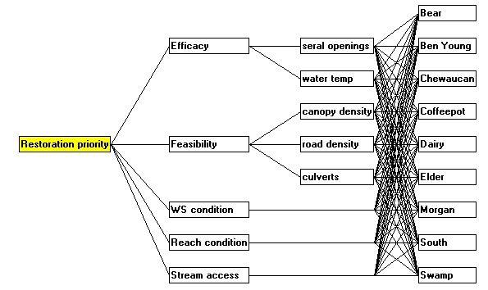
Figure. A CDP model to determine priorities for watershed restoration. Here, the alternatives are spatial elements of the landscape (watersheds).
- The SMART approach
  - Utility functions
    - Map observed attribute values into measures of utility – normalization!
    - E.g., how well does the observed value satisfy the criterion?
- Combining AHP and SMART – Criterium DecisionPlus
  - Practical issues for spatial analysis (e.g., pair-wise comparisons of landscape elements)
  - Minimizes some theoretical problems with the pure AHP
    - The rank reversal problem
- Use decision-support features of CDP
  - Contributions of criteria
  - Sensitivity analysis
  - Trade-off analysis

Contemporary, integrated systems
- There are many!
  - Have a look at the FORSYS COST Action 0804 http://fp0804.emu.ee/wiki/index.php/Category:DSS
- What I mean by integrated systems
  - An integrated system will typically contain some or all (very rare!) of the following components
    - A GIS platform (ArcGIS, GRASS, IDRISI, etc.)
    - A database management system
    - An optimization system (goal programming, mixed-integer programming, etc.)
    - A knowledge-based system (rule-based, Bayesian, blackboard, agent-based, etc.)
    - One or more simulators (lots of possibilities here)

Reading
- Thompson, M.P. B.G. Marcot, F.R. Thompson, III, S. McNulty, L.A. Fisher, M.C. Runge, D. Cleaves, and M. Tomosy. 2013. The Science of Decisionmaking: Applications for Sustainable Forest and Grassland Management in the National Forest System. General Technical Report WO-88. USDA Department of Agriculture, Forest Service, Washington, DC.

Additional references
- Holsapple, C.W., 2003. Decision support systems. In: Bidgoli, H. (Ed.), Encyclopedia of Information Systems, vol. I. Academic Press, New York, pp. 551–565.
- Johnson, K.N., Stuart, T.W., Crim, S.A., 1986. FORPLAN. Version 2: An Overview. U.S. Department of Agriculture,Forest Service, Land Management Planning, Washington, DC.
- Kamenetzky, R. 1982. The relationship between the analytical hierarchy process and the additive value function. Decision Sciences. 13: 702-716.
- Mintzberg, H., Raisinghani, D., Theoret, A., 1976. The structure of unstructured decision processes. Admin. Sci. Quart. 21, 246–275.
- Nyberg, J.B., B.G. Marcot, and R. Sulyma. 2006. Using Bayesian belief networks in adaptive management. Can. J.For Res 36: 3104-3116.
- Rauscher, H.M., 1999. Ecosystem management decision support for federal forests in the United States: a review. Forest Ecol. Manage. 114, 173–197.
- Saaty, T.L. 1992. Multicriteria decision making: the analytical hierarchy process. Pittsburgh, PA: RWS Publications.
- Walters, J.R., Nielsen, N.R., 1988. Crafting Knowledge-based Systems. Wiley, New York.
- Zadeh, L.A. 1965. Fuzzy sets. Information and Control. 8: 338-353.
- Zadeh, L.A. 1968. Probability measures of fuzzy events. Journal of Mathematical Analysis and Applications. 23: 421-427.
- Zadeh, L.A. 1975a. The concept of a linguistic variable and its application to approximate reasoning, part I. Information Science. 8: 199-249.
- Zadeh, L.A. 1975b. The concept of a linguistic variable and its application to approximate reasoning, part II. Information Science. 8: 301-357.
- Zadeh, L.A. 1976. The concept of a linguistic variable and its application to approximate reasoning, part III. Information Science. 9: 43-80.

